**Preliminary Analysis Stage:**

Here we plotted the number of average daily breaks the participants took per day against the flourishing scores. We used the 3-month data to prove or disprove our initial hypothesis, which stated that people who took 4 or more daily breaks reported higher scores on the flourishing scale than those who took 2 or less breaks on average. Flourishing scores measure happiness and life satisfaction, mental and physical health, sense of meaning and purpose, financial and material stability, and others, questions spam 6 domains and answers are given on a scale 1-10. The flourishing scores used in this data are the sums of all the answers.

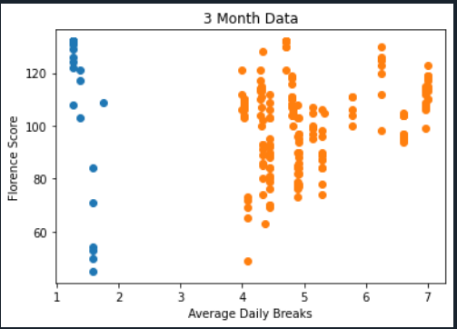

We observed that people who took 2 or less breaks on average reported similar scores to those who took 4-5 breaks, but participants who took 6 or more breaks reported higher scores on the flourishing scale. However, it is important to note that significantly more people took >= 4 breaks, and scores of those who took 2 or less breaks were more polarized. In other words, participants who took 2 or less breaks mostly reported very high levels of physical and mental wellbeing, or very low levels. In contrast, people who took 4 or more breaks demonstrated scores that were more evenly distributed.

Looking at the 6 month data, our goal was to see if there were any observable differences. The scatterplot for the updated dataset is pictured below. The main thing to note is that the mean flourishing score of individuals who took 2 or less breaks increased from 108.46 to 113.63, which equates to a nearly 5% increase.

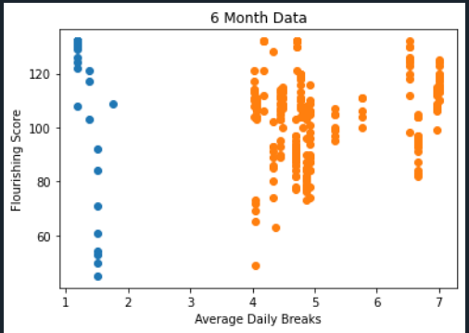

**Correlating Flourishing Scores with E-work Life Scale:**

*Hypothesis:* Subjective well-being (as measured by a score on the Flourishing Scale) will correlate positively with the E-Work Life score.

Include: without breaks. Include statistical analysis with p value.

The E-Work Life Scale was measured by a survey comprising four categories: Organizational Trust, Flexibility, Work-Life Interference, and Effectiveness/Productive. Each of the categories included questions that individuals were supposed to answer on a scale from 1 to 5 (1 being strongly agree and 5 being strongly disagree).

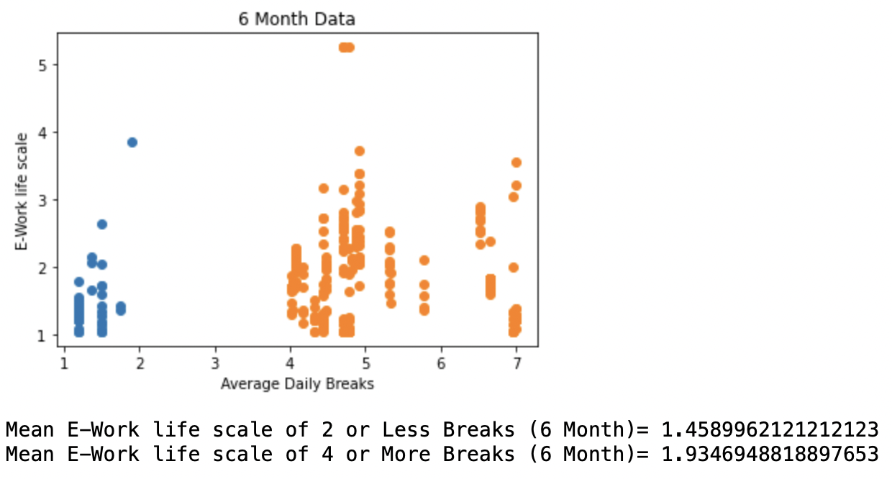

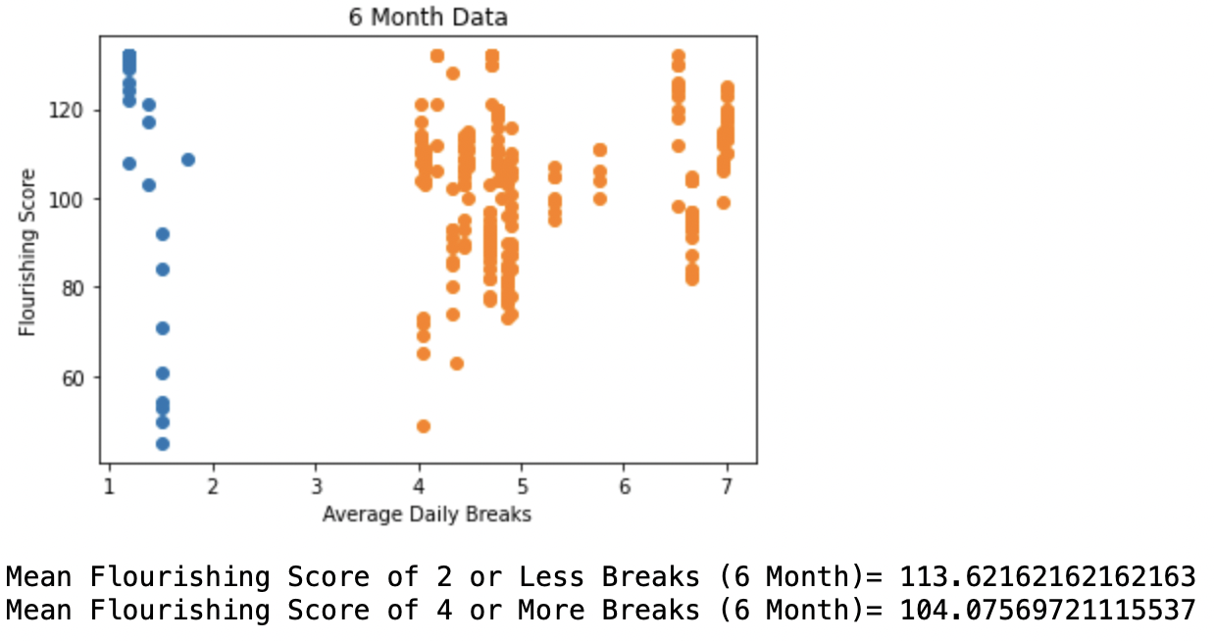

By analyzing the 6 month data, we observed that individuals who took two or less breaks per day presented an average E-Work Life score that was lesser than those who took four or more breaks. This discovery supports the hypothesis since an analysis of the flourishing scores for those individuals showed that the flourishing scores for 2 or less breaks was greater than 4 or more breaks. It is important to note, however, that even though the subjective well being of individuals was positively correlated with their E-Work Life score, the difference between the well being and E-Work Life scores of individuals who took two or less breaks and four or more breaks was not significant.